“A Matter of Balance” ©
Do you have a FEAR of Falling ?
Do you stay home and avoid being active?
Learn what YOU can DO to MANAGE your fear

Each program offered in weekly classes – 2 hours each week for 8 weeks
No charge Space is limited Pre-registration is requested
Where:
Gatesville Senior Center
208 N Lutterloh Ave.
Gatesville, Texas
When:
9:30 AM till 11:00 AM
May 5, 12, 19, 26
June 2, 9, 16, 23
Wednesday Mornings

Topics –
- Understanding your fears
- Staying active through easy exercises
- Learning to communicate with your family and healthcare team
- Making safety improvements at your home
- Delaying complications
- Changing “Fall-ty” Habits

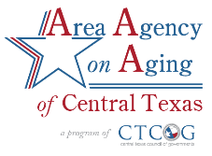
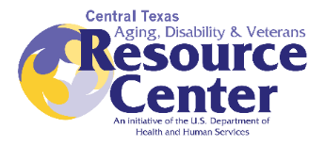
To register or for more information please contact:

Theresa Mireles 254-770-2330 or theresa.mireles@ctcog.org therethereesa\\\\\The
Th

